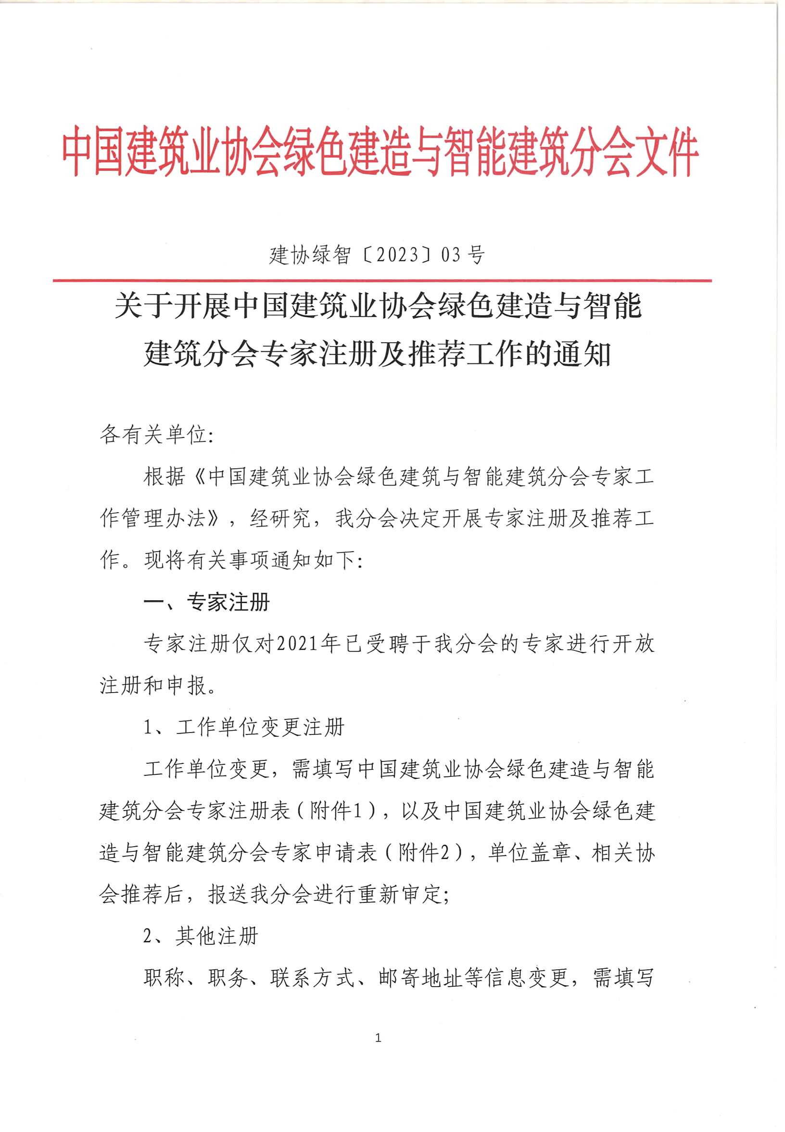

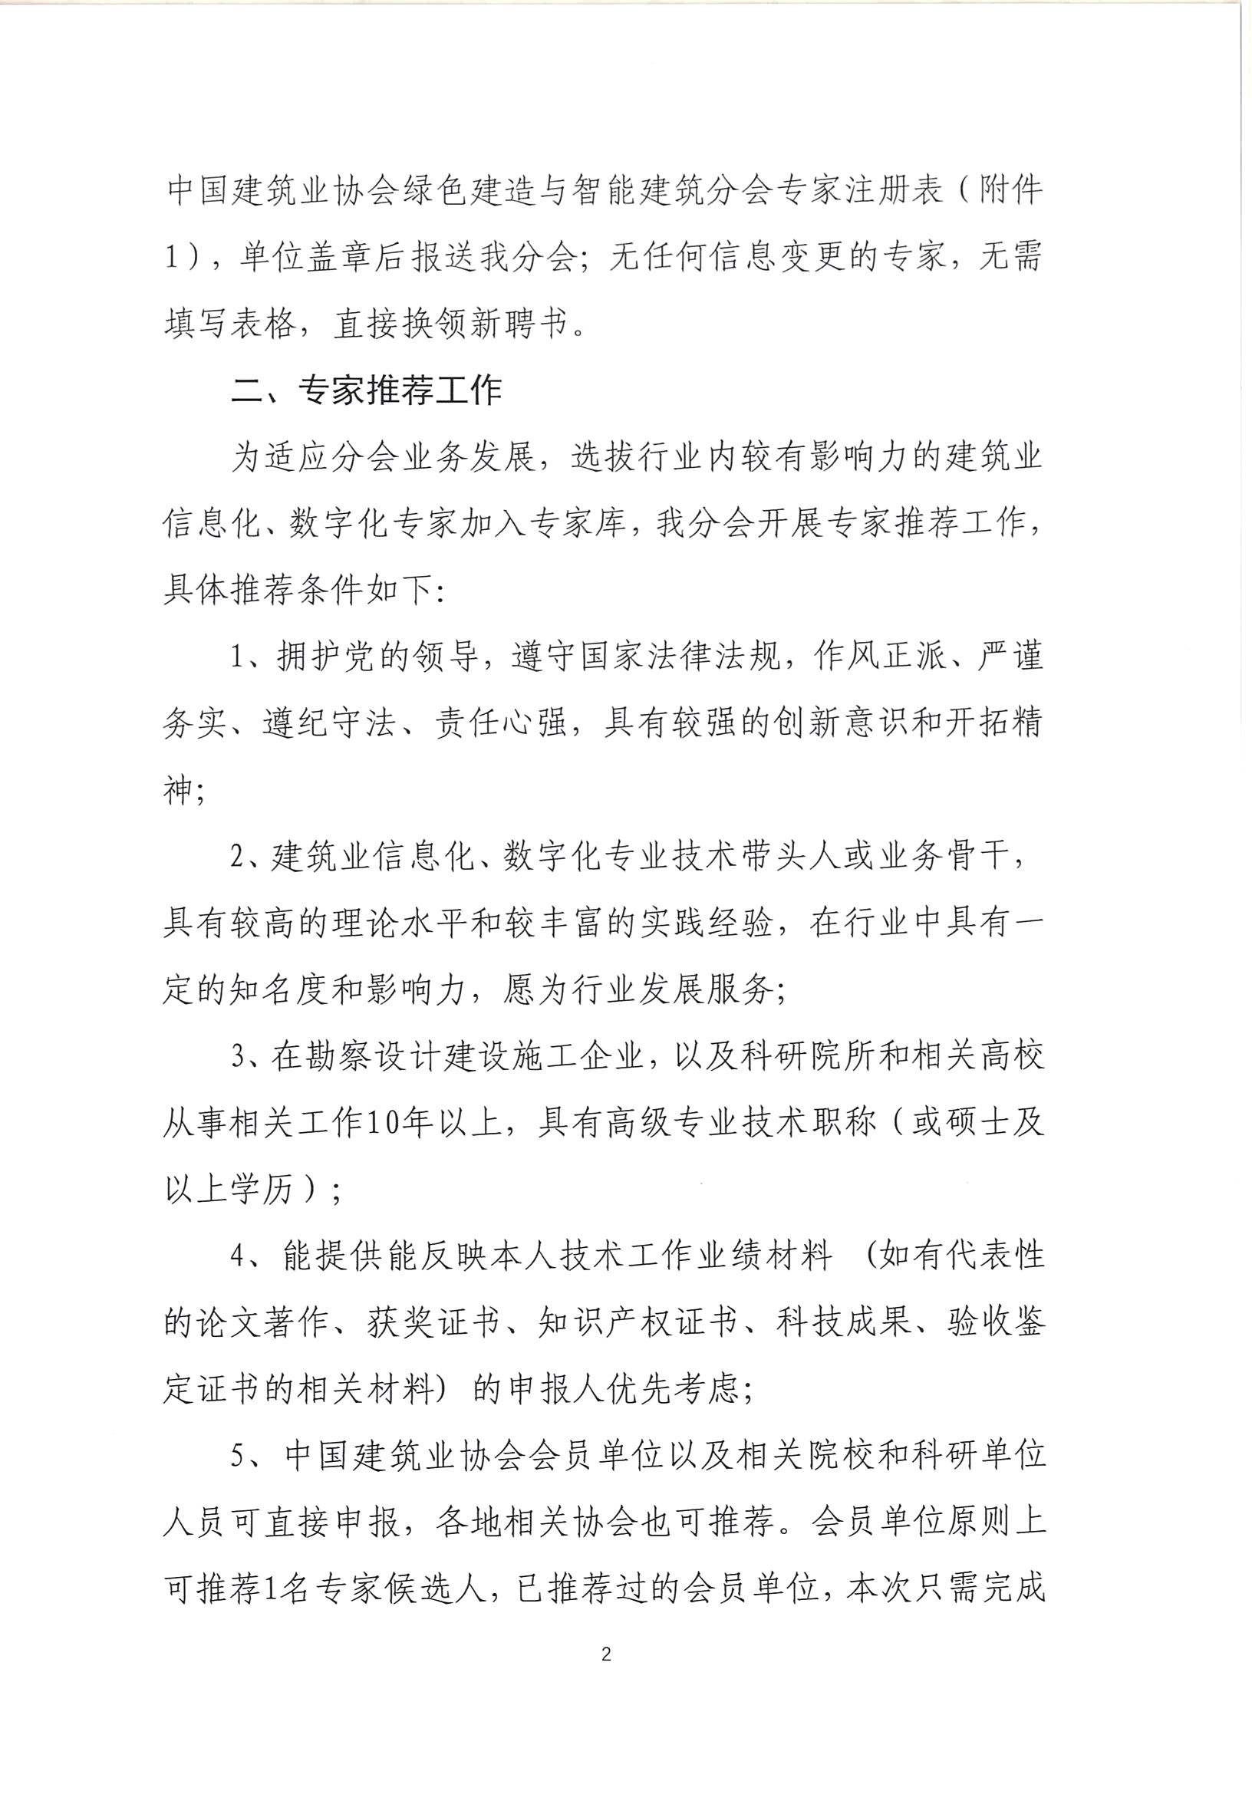

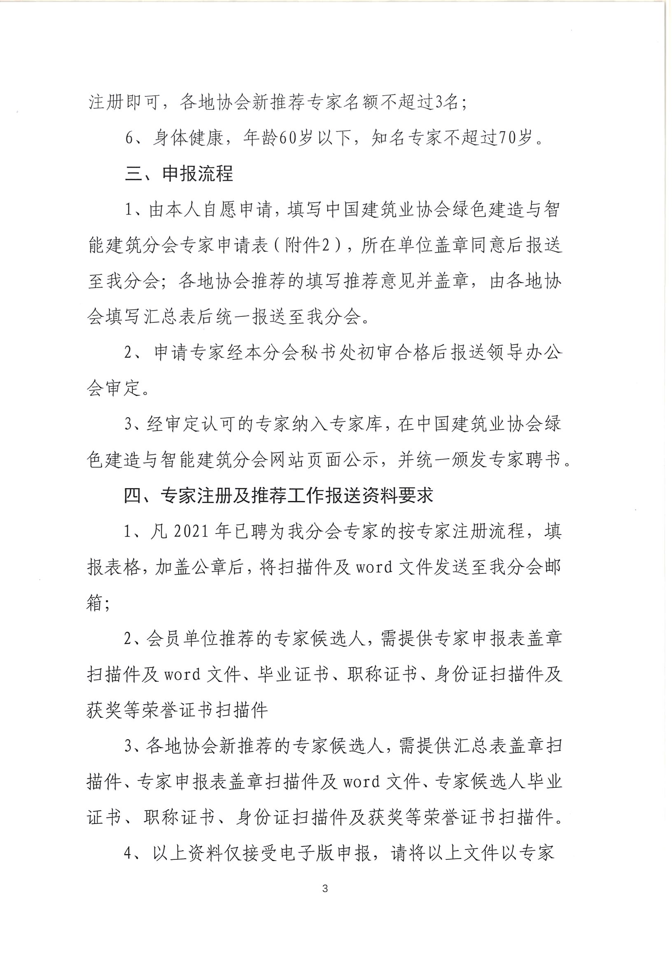 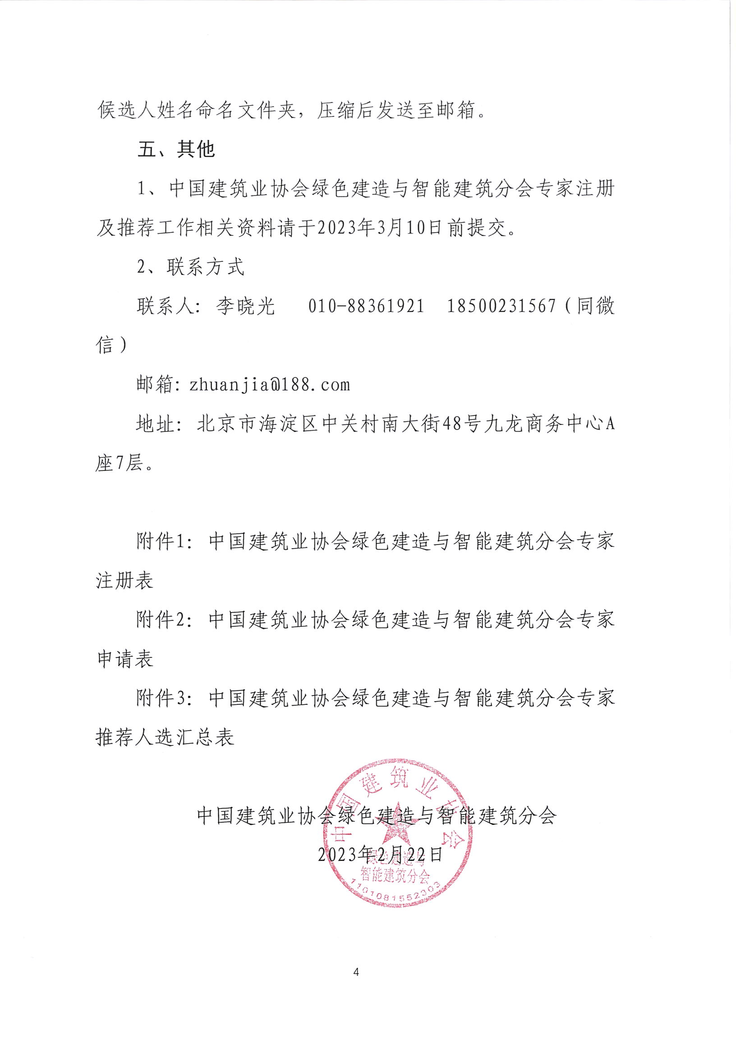附件1：

中国建筑业协会绿色建造与智能建筑分会

专家注册表

|  |  |  |  |  |  |
| --- | --- | --- | --- | --- | --- |
| **姓名** |  | **出生年月** |  | **性别** |  |
| **学历** |  | **所学专业** |  | **职称** |  |
| **身份证号** |  | | **毕业院校** |  | |
| **联系电话** |  | | **电子邮箱** |  | |
| **通讯地址** |  | | | **邮政编码** |  |
| **原工作单位** |  | | | **原职务** |  |
| **现工作单位** |  | | | **现职务** |  |
| **工作简历** |  | | | | |
| **主要业绩** |  | | | | |
| **培训经历** |  | | | | |
| **现单位意见** | **（单位盖章）**  **年 月 日** | | | | |

附件2：

中国建筑业协会绿色建造与智能建筑分会

专家申请表

|  |  |  |  |  |  |  |  |  |  |  |  |  |  |
| --- | --- | --- | --- | --- | --- | --- | --- | --- | --- | --- | --- | --- | --- |
| **姓 名** |  | | **出生年月** |  | | | **性 别** | | |  | | **贴**  **相**  **片**  **处** | |
| **学 历** |  | | **所学专业** |  | | | **职 称** | | |  | |
| **身份证号** |  | | | **毕业院校** | |  | | | | | |
| **工作单位** |  | | | | | | **工龄** | | | |  |
| **现从事**  **专业方向** |  | | **从事本专业年限** |  | | | **职 务** | | |  | | | |
| **单位电话** |  | | **手 机** |  | | | **传 真** | | |  | | | |
| **邮政编码** |  | | **电子邮件** |  | | | | | | | | | |
| **通讯地址** |  | | | | | | | | | | | | |
| **工**  **作**  **简**  **历** |  | | | | | | | | | | | | |
| **主**  **要**  **业**  **绩** |  | | | | | | | | | | | | |
| **培训经历** |  | | | | | | | | | | | | |
| **熟悉专业及其代表作** | | | | | | | | | | | | | |
| **所熟悉专业** | **熟悉程度**  **(熟悉、较熟悉、一般熟悉)** | | **代表性论文、著作或成果** | | | | | **期刊名，出版时间或鉴定验收编号** | | | | | |
|  |  | |  | | | | |  | | | | | |
|  |  | |  | | | | |  | | | | | |
|  |  | |  | | | | |  | | | | | |
| **近五年从事的主要研究项目** | | | | | | | | | | | | | |
| **项目名称** | | **项目来源** | | | **立项年月** | | | | **A负责人**  **B参加者** | | | | **A在研**  **B完成** |
|  | |  | | |  | | | |  | | | |  |
|  | |  | | |  | | | |  | | | |  |
|  | |  | | |  | | | |  | | | |  |
|  | |  | | |  | | | |  | | | |  |
|  | |  | | |  | | | |  | | | |  |
| **单**  **位**  **意**  **见** | **（单位盖章）**  **年 月 日** | | | | | | | | | | | | |
| **各省市**  **行业协**  **会或有**  **关单位**  **推荐意见** | **（单位盖章）**  **年 月 日**  ＊由地方协会推荐的专家此项需盖章 | | | | | | | | | | | | |
| **分**  **会**  **意**  **见** | **（单位盖章）**  **年 月 日** | | | | | | | | | | | | |

附件3：

中国建筑业协会绿色建造与智能建筑分会专家推荐人选汇总表

|  |  |  |  |  |  |  |  |  |  |  |
| --- | --- | --- | --- | --- | --- | --- | --- | --- | --- | --- |
| **序号** | **姓名** | **工作单位** | **职务** | **职称** | **学历** | **现从事领域和专业** | **联系电话** | **邮箱** | **身份证号码** | **通讯地址** |
|  |  |  |  |  |  |  |  |  |  |  |
|  |  |  |  |  |  |  |  |  |  |  |
|  |  |  |  |  |  |  |  |  |  |  |
|  |  |  |  |  |  |  |  |  |  |  |
|  |  |  |  |  |  |  |  |  |  |  |
|  |  |  |  |  |  |  |  |  |  |  |

推荐单位(盖章）：

联系部门： 联系电话： 联系人： 填表日期：